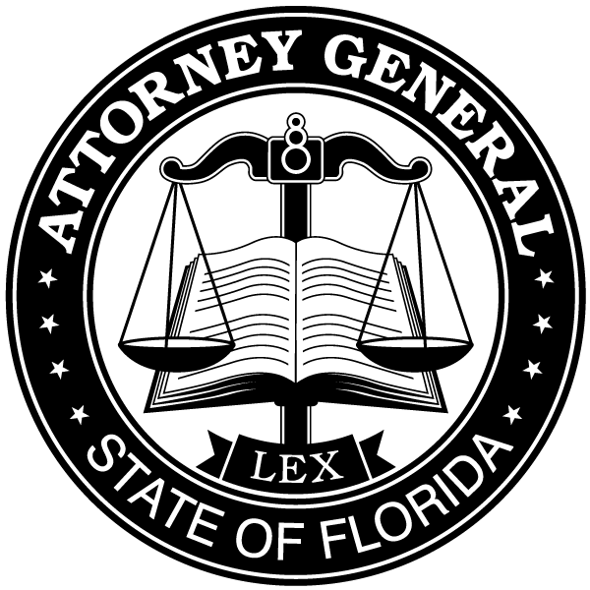
OFFICE OF THE ATTORNEY GENERAL
Division of Victim Services and Criminal Justice Programs

PL-01 The Capitol
Tallahassee, FL 32399-1050
Phone (850) 414-3300 Fax (850) 487-3013
http://www.myfloridalegal.com

ASHLEY MOODY ATTORNEY GENERAL
STATE OF FLORIDA

December 2021

NOTICE OF AVAILABILITY
VOCA Grant Funds

Announcement: The Office of the Attorney General (OAG) is pleased to announce the availability of Victims of Crime Act (VOCA) grant funds from the U.S. Department of Justice. The purpose of the VOCA grant reimbursement program is to support the provision of services to victims of crime. Services are defined as those efforts that respond to the emotional and physical needs of crime victims, assist victims of crime to stabilize their lives after victimization, assist victims to understand and participate in the criminal justice system, and provide victims of crime with a measure of safety and security. Eligibility to apply for VOCA funds is limited to victim assistance programs administered by state or local government agencies or not-for-profit corporations registered in Florida, or a combination thereof, that can demonstrate the following:

- proof that the Internal Revenue Service recognizes the organization as being tax exempt under 501(c)(3) of the Internal Revenue Code;
- a statement from a state taxing body or state secretary of state certifying that the organization is a nonprofit organization and that no part of the organization's net earnings may benefit any private shareholder or individual;
- a certified copy of a certificate of incorporation or similar document establishing nonprofit status; or
- any of the above, if it applies to a state or national parent organization, with a statement by the state or national parent organization that the applicant is a local nonprofit affiliate.

The funding cycle for the VOCA grant funds under this notice is October 1, 2022, through September 30, 2023.

Application and Deadline: Organizations may participate in the annual competitive grant process which involves submission of an application followed by an application review.

The VOCA application may be accessed using the Office of the Attorney General’s online system EGrants, which can be accessed through https://egrantsigx.myfloridalegal.com/ on January 3, 2022. If you need assistance you may contact (850) 414-3380 or email contact.voca@myfloridalegal.com.

Technical assistance webinar trainings on VOCA application completion are scheduled. It is strongly encouraged that agency staff who will be completing the grant application in the EGrants system register for and participate in one of the training sessions, provided on the following dates. All three training sessions will provide the same information on application completion. To participate in a training session, you must use the link included with the selected date.

January 6, 2022 10:00 am to 12:00 pm EST
Registration link: https://attendee.gotowebinar.com/register/6892459482592906766

January 12, 2022 1:00 pm to 3:00 pm EST
Registration link: https://attendee.gotowebinar.com/register/8549833623488643595

January 21, 2022 10:00 am to 12:00 pm EST
Registration link: https://attendee.gotowebinar.com/register/7509330585752147728

The deadline for applying for a VOCA grant under this notice is no later than 5:00 p.m. Eastern Standard Time on Friday, February 11, 2022. Applicant agencies are encouraged to submit the completed application as soon as possible prior to the deadline. Mailed, faxed, or hand delivered applications or required documentation will not be accepted.

